FABI

the Flexible Assistive Button Interface

“Do-It-Yourself” - Building Guide

for selfmade box / breadboard version

and selfmade buttons

# C:\Users\chris veigl\Desktop\Flip&Fabi_Fotos\bearbeitet\IMG_0927_2.JPGasterics_academy_logo_vd4

# Welcome to FABI

The FABI (Flexible Assistive Button Interface) allows control of a computer’s mouse cursor and typing desired keyboard keys by using buttons and special/individual input methods. It can be helpful for people who cannot use standard computer input devices – enabling them to play games, surf the internet, write emails and much more.

The FABI Interface can be actuated via dedicated buttons, momentary switches or self-made electrical contacts. FABI consists of a hardware module (a low-cost microcontroller which behaves as a computer mouse and/or keyboard) and a graphical software application for configuration of the desired functions.

FABI is an open source Assistive Technology module developed by the AsTeRICS Foundation

(see <http://www.asterics-foundation.org/>).

All software and hardware documents are open source and we took care to use the most affordable components available on the market to establish these functionalities – making FABI the most reasonably priced flexible assistive button interface in the Universe !!

### About this Document

This construction manual is a “do-it-yourself” building guide for your personal FABI device, describing the necessary hardware components and the prerequisites for making a FABI on a breadboard or with custom switch contacts.

The Graphical User Interface application for configuration and the construction of the 3d-printed version is described in separate documents.



# Contents

[1](#_Toc66131609)

[Welcome to FABI 2](#_Toc66131610)

[About this Document 2](#_Toc66131611)

[Contents 3](#_Toc66131612)

[Building the Hardware 4](#_Toc66131613)

[Make your own Switches 8](#_Toc66131614)

[Soldered Connections 11](#_Toc66131615)

[Building you own FABI Box 13](#_Toc66131616)

[List of needed material 17](#_Toc66131617)

[Material for building and soldering your own FABI Box: 18](#_Toc66131618)

[Contact Information 19](#_Toc66131619)

[Disclaimer 19](#_Toc66131620)

[Acknowledgement 19](#_Toc66131621)

**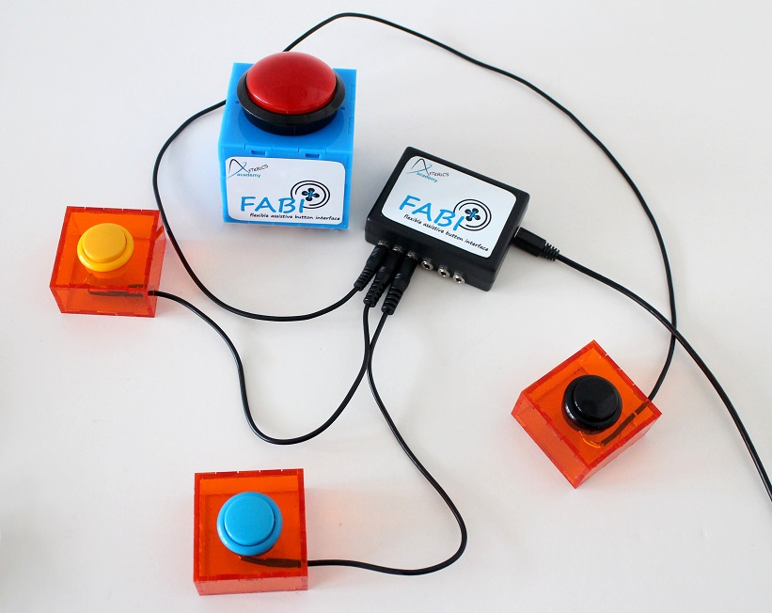**

# Building the Hardware

Building your own FABI interface for computer control is easy! Here, we will show what you need and how to assemble the parts, and we will give some ideas how to build your own alternative input variants using creative low tech solutions.

A working FABI device consists of a microcontroller with USB cable and some additional electrical connections (wires, switches, buttons) – which can be mounted in a way so that they are easily accessible for the user(s).

#### The microcontroller

The microcontroller is the “brain” of the FABI interface. It monitors which button a user presses and creates the desired/associated mouse- or keyboard activities! The microcontroller is a programmable electronic circuit (actually a small computer on a chip) which can execute the programmed software and performs measurement- and control tasks. Theoretically, various microcontrollers could be used to build a FABI interface – as long as they support the USB HID protocol which makes them compatible to computer mouse- or keyboard devices. In our project, we decided to use an Arduino Pro Micro controller for circa $4,50 ! This microcontroller has a USB-Port where it can be connected to any computer (Windows, Mac, Linux).

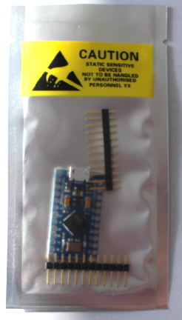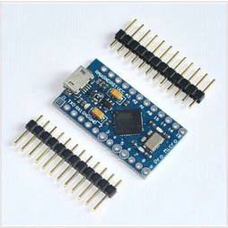

Figure 1: example of Arduino Pro Micro clone which can be used (4,50 $),

We created the necessary software which is now available as open source and can be stored into the microcontroller using the free Arduino Integrated Development Environment. The process of programming the microcontroller is described later in the software section of this manual.

#### Using breadboards for prototyping

The easiest way to connect electrical components (as for example wires and switches) to the microcontroller is a breadboard. A breadboard has mounting holes for components or wires, as well as internal electrical connectors called “bars” and “rails”: The bars are connected vertically (expect for the bridge in the middle) and the rails are connected horizontally, see figure below (right). The black mini breadboard shown on the photo below (left) features only bars, no rails.

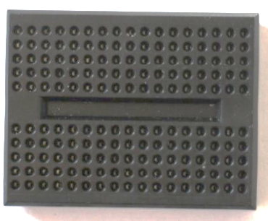 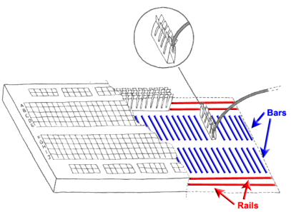

Figure 2: a minimal Breadboard (left), internal connections of a breadboard (right)

Breadboard prototypes are especially useful if you don’t want to use your construction for a long time or you want to experiment a lot, because the connections are very flexible and easily changeable. For long-term usage, a soldered construction should be used because it’s more robust – especially when you found a reasonable assistive configuration which helps other persons !

When you buy a “naked” Arduino Pro Micro microcontroller from a shop or online store, you probably must solder so-called “pin headers” to the pin holes before you can insert the microcontroller into the breadboard. Afterwards you can connect wires to the desired pins via the breadboard. A controller with pin header connectors attached looks similar to this:

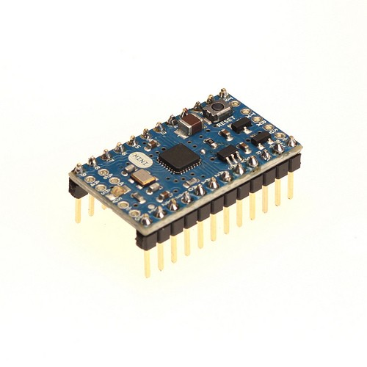

Figure 3: A microcontroller (here: Arduino mini) with pin header connectors attached

#### The basics of soldering

The usage of a soldering iron for connecting electric/electronic components is easy - if you pay attention to a few things. An excellent guid to soldering is available here: <https://learn.adafruit.com/adafruit-guide-excellent-soldering/>

**Important safety rules:**

* **Never touch the tip of the soldering iron**- it gets over 300 deg. celsius !
* **If your solder contains lead, pay attention that it is not touching your skin and that you do not inhale the poisonous smoke**
* **Put the soldering iron always back into its stand**

1. Hold the soldering iron in your dominant hand (like you would hold a pencil).   
   In your other hand you hold the solder
2. Heat up the metal part where you want to connect to with the cleaned tip
3. Add about 1mm to 3mm of solder, heating up all parts for a short time
4. Remove the tip and let the solder joint cool down

|  |  |  |
| --- | --- | --- |
|  |  |  |

Figure 4: Basic steps of soldering © MightyOhm, <http://mightyohm.com/blog/2011/04/soldering-is-easy-comic-book/>

#### Soldering the pin header to the controller:

Cut 2 male pin headers to the correct length for the microcontroller (if not already provided), put the small ends through the connector holes of the controller and fix the three parts in a stable position for soldering. Maybe the best idea is to put everything already into the breadboard which gives a good stability. (don’t touch the pin header connections while solder – yes – they get hot ;-)

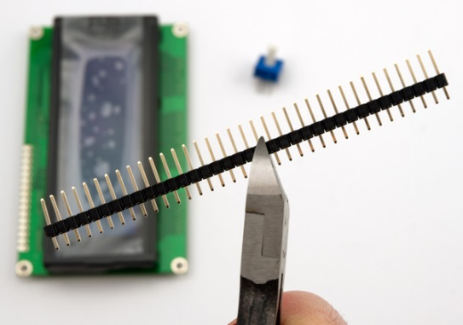 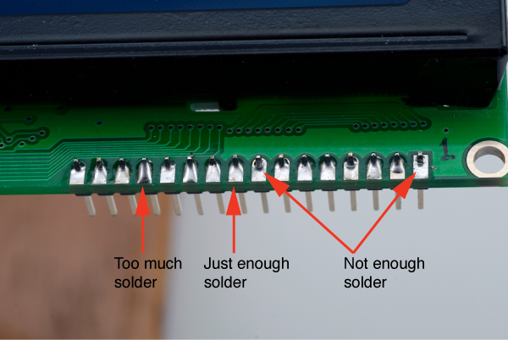

Figure 5: Cutting the male pin header, applying right amount of solder

#### Attaching wires to the microcontroller:

For connecting a switch to the microcontroller we need to attach one wire to the ground potential (zero volts, labelled “GND” at the microcontroller). Then we attach another wire to another “Pin” – you can choose one from 2-7 as these are supported in the software. At these pin connections, the microcontroller then receives the ground potential when the switch will be pressed.

**Remove the isolation from the wires on both ends, so that you can insert the bare metal wire into the breadboard. Make sure that at least 5mm bare wire goes into the breadboard connection.**

The finalized microcontroller with soldered pins and two attached wires should now look similar to this:

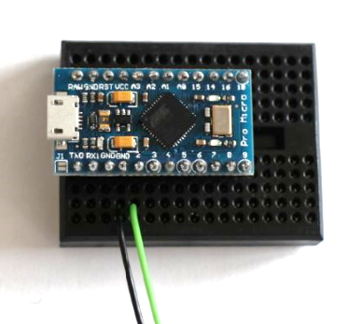

Figure 6: How to connect wires with microcontroller,   
here using a breadboard: black wire for GND pin, green wire for input / signal pin 2

The FABI software is programmed so that we can use any pin from 2 to 7 to attach the ground potential. The microcontroller will then react by performing one out of 6 functions which can be defined in the configuration software**.**

The two bare wire ends which now stand off can act as a simple switch: By connecting them you trigger the signal to the microcontroller so that the desired actions can be performed. This represents the most basic switch possible …

## Make your own Switches

Switches are a simple method for computer control – if supported well in the computer software and/or operating system. Accessible switches are supported by various kinds of assistive software applications like On-Screen-Keyboards or Alternative Augmented Communication grids. A standard accessible switch (without the computer control box) can cost 100 $ or more if you buy it from a professional reseller – this is 10 times the cost of our whole FABI device ….

Switches attached to FABI can create many different computer input actions like all kinds of mouse clicks, mouse movement and more (see the software section for details). The only things you need to add to your microcontroller are suitable wire connections and switch contacts for the user. In the following, a few simple ways to create different switch contacts will be presented:

#### The most simple switch: Two connected wires !

The simplest switch is built of two wires which are connected to pin and to the ground pin (GND) of the microcontroller. If the two wires do not touch each other, there is no connection between the two pins and no signal is received. If the two wires touch each other, the resistance is decreased and the microcontroller receives the ground signal – so it can detect that the button was pressed.

|  |  |
| --- | --- |
| No Signal | Signal |
|  |  |

Figure 7: Simple switch made out of two wires, left picture: switch is inactive; right picture: switch is activated

#### Cardboard / foil - switch

The cardboard / foil switch works the same way as the simple wire connection described above, but it is more user friendly because you can use the cardboard as a haptic momentary contact switch and press it with different limbs / fingers / even toes ! – And: it costs next to nothing !

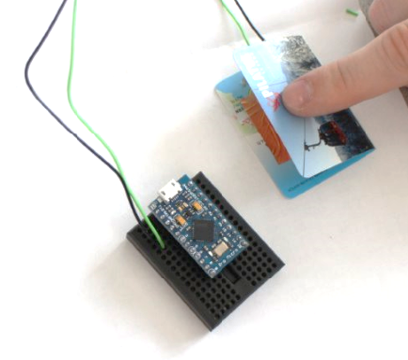

Figure 8: Cardboard / foil switch

Here we used copper foil (you could also use aluminum foil) and a piece of thick paper (e.g. a business card of someone you will never contact ;-) to build the accessible switch:

|  |  |  |
| --- | --- | --- |
|  |  |  |

Figure 9: material for low tech switch: left picture: piece of carton, middle picture: copper foil, right picture: switch wire

Fold the carton in the middle like in figure 8. Afterwards stick the two pieces of foil, one of each side of the inner areas of the cartoon including a wire between cartoon and foil on each side (see figure 10).

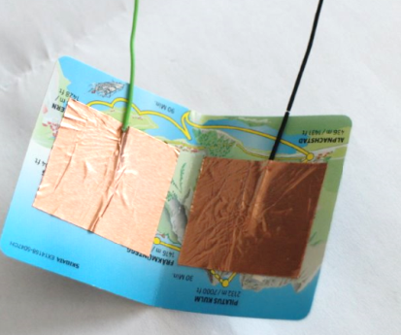

Figure 10: copper foil and the two wires stick on the inner side of the carton

Now connect the wire to the microcontroller like in figure 8. By pressing the upper side of the cartoon to the underside of the cartoon together that the two foil pieces can connect, the switch is activated. For mounting the cardboard / foil switch in a convenient position, velcro-tape or double-sided sticky tape could be reasonable methods …

#### Re-using an existing switch

There are various possibilities for finding switches in old electrical or household devices. In fact, all you need are two metal contacts ! – You can use an old light switch or an on/off switch of an old radio – the options are endless. Here we show a microswitch which can be found e.g. in several computer joysticks. Of course you can also buy one from the store ;-)

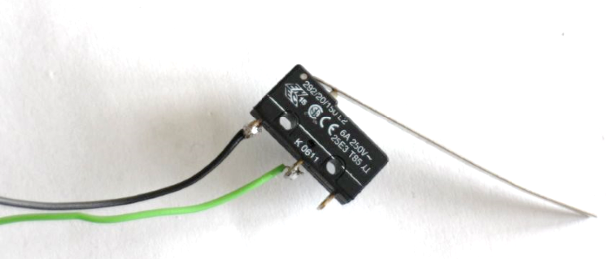

Figure 11: (Re-)using an existing switch

To solder the wires to the switch, the best is to fixate the switch in a vice. Then connect the wires to the switch using solder, as shown in figure 12.

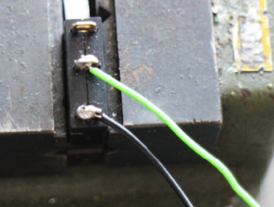

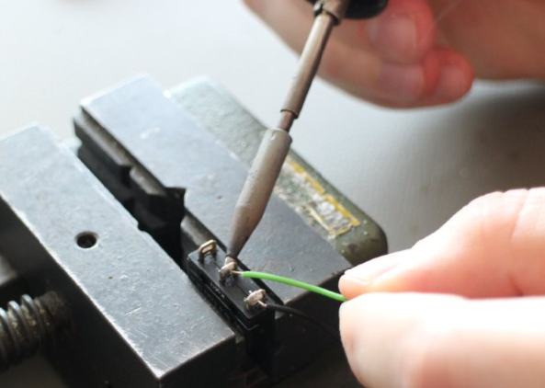

Figure 12: how to solder the wires to the switch

## Soldered Connections

If you want to use your device for a longer period or you found a helpful configuration for another person, your solution should be very robust and stable. It will be a good idea to remove the breadboard and solder the wire connection directly to the microcontroller.

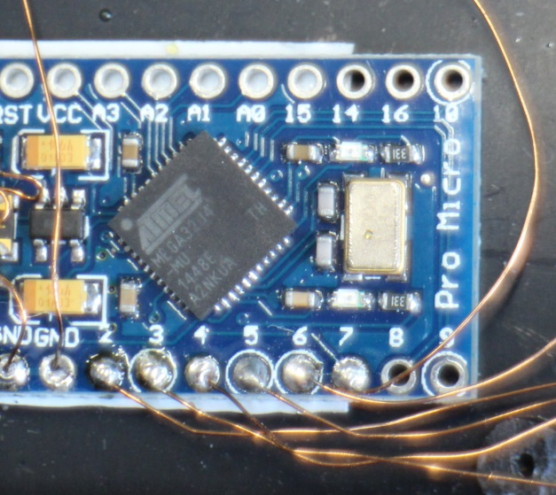

Figure 13: Wires are directly soldered to   
single pins of the microcontroller

For soldering, follow the basic soldering introduction above. Pay attention that you do not burn the device by applying too much heat to the pins (5 seconds at about 350 degrees Celsius should be fine). The figure above shows a new microcontroller (without pre-soldered male pin headers). Here, enameled copper wire was used for the connections – you can also attach other wires of course but pay attention not to create short circuit connection to other pins via loose wire parts…

If you already attached the male pin headers (figure 3), they will be difficult to remove. In this case it might be better to buy female pin header connectors where you can attach the microcontroller without removing the male pin headers. You can then solder your wires to the ends of the female pin header connectors. Thereby you create a stable but still removable connection. Here a picture of suitable female connectors

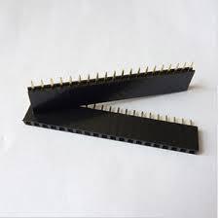 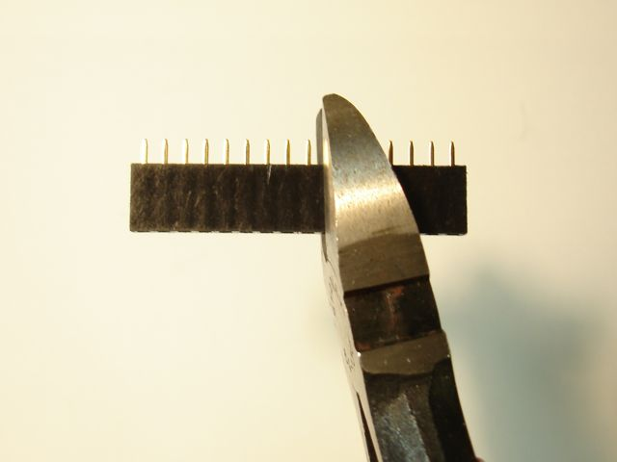

Figure 14: Female pinheader connectors

#### Connect switches via jack plugs and stereo cable

It might be reasonable to solder the wires from the microcontroller to a 3,5mm stereo (or mono) jack plug. With this solution you have the possibility to connect a variety of input methods to the jack plug via a stereo audio cable. You could also connect standard accessible switches which (most probably) come with a 3,5mm mono jack plug.

Solder one wire to a GND-pin of the microcontroller and another wire to the desired input pin (labelled 2 – 7 in case of the Arduino Pro Micro). The other end is soldered to the 3,5mm jack plug as shown in figure 14: The long end of the jack plug should be connected to the ground wire on of the shorter end to the pin-wire. Now you can easily connect any device with a stereo cable to your jack plug.

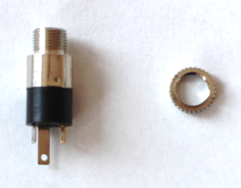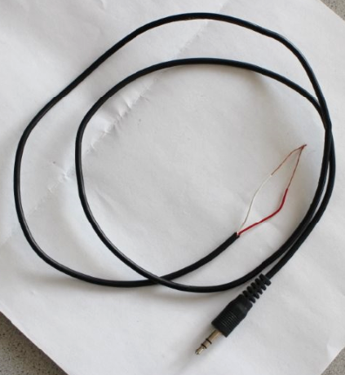

|  |  |
| --- | --- |
| Receive Pin |  |

GND

Figure 15: left picture: jack plug, right picture: stereo cable

|  |  |
| --- | --- |
|  |  |

Figure 16: how to solder two wires to a mono plug

Unscrew the tip of the jack plug. Then connect the ground wire and pin wire as shown in the left pictures above using the soldering iron. After successfully finishing the soldering step, you can screw the housing of the stereo cable as shown in the right picture above.

## Building you own FABI Box

|  |  |
| --- | --- |
|  | Figure 17: FABI box |

If you would like to protect your microcontroller in a nice case and add flexible connectors, it might be an idea to build a FABI box with 6 jack plugs, to connect 6 different switches to the microcontroller pins 2, 3, 4, 5, 6 and 7. You can use any box of choice with a size of about 85 x 65 x 28mm or buy the box seen above at the webshop of <http://www.reichelt.de> (the part number is SP-2062-SW). The 6 switches can then be configured with the FABI GUI software for different alternative computer control functions as explained in next chapter “Software”.

|  |  |
| --- | --- |
|  | The first step to build a FABI box is to mark the drill holes for the 6 jack plugs (long side of the box) and the USB connection (short side of the box).  It is important that the single jack plugs are far enough away from each other that the plugs can be inserted later. The distance between two plug holes should be at least 10mm. Pay attention that the holes are in the middle of the box! |
|  | Fix the box with the vice |
|  | With a pointed punch and a hammer the holes which should be drilled are marked for an easier handling with the big drill |
|  | After the preparation explained above, make the holes for the jack plug and the USB cable carefully with a stationary table driller (6mm drill)  But before using the drill, please read the user manual carefully!  Pay attention to your body especially the fingers! Always use the vice while working with the drill |
|  | Now the box should have 6 holes for the jack plugs and one bigger hole for the USB cable (can be extended with a file ) |
|  | Remove all disturbing plastic elevations inside the box |
|  | Strip the isolation off of a wire cable to get a bare conductive wire (length: ca. 7 cm) |
|  | Then you can start to screw the jack plugs into their mounting holes and connect their longer connections with the wire (this will supply the ground connection to all jack plugs).  (put the wire through the small holes in the longer end of the jack plug) |
|  | Solder the wire and the long ends of the jack plugs together |
|  | Now it is time to connect the single pins to the jack plugs. For these connections, enameled copper wire is used which is very thin and flexible.  **Attention:**  For an electric connection it is necessary to remove the isolation from the ends of the copper wire. This can be done by adding solder and heating the ends several seconds with the soldering iron. Make sure that the isolation layer is 100% removed ! |
| Figure 18: The finished guts of a FABI box | Cut pieces of short copper wire and connect the single pieces to the pins (2-7):  Fill the pin hole on the microcontroller up with solder then heat the solder in the pin hole again and add the copper wire. Attention: it takes about one second till the solder is tight again; therefore you have to work fast and precise!  Then connect the copper wire from each pin to the dedicated jack plug (smaller end)  One copper wire is used to connect the bare wire (leading to every jack plug) with a GND pin of the microcontroller  In the end your result should look like the picture on the left side: every pin is connected to one jack plug end and the ground connection is also connected to the microcontroller  Now you can screw the cover to the box and download the software as described in the next section |

## List of needed material

|  |  |
| --- | --- |
| **Microcontrollers**  and breadboard | * Arduino Pro Micro (or clone) - or alternatively Teensy 2.0++:   get it from: [http://www.aliexpress.com/snapshot/6508733198.html](http://www.aliexpress.com/snapshot/6508733198.html?orderId=65920185657484)  or <https://www.sparkfun.com/products/12640>  or <https://www.pjrc.com/teensy/>   * A small Prototyping-Breadboard get it from:   <http://www.aliexpress.com/popular/solderless-breadboard.html> |
| **Switch-solutions** |  |
| Connecting two wires | * isolated wires (if possible: black and colored) do not use stranded wire but single metal leads |
| Cardboard / foil switch | * Piece of cardboard * Copper foil / aluminum foil (if possible: self-adhesive) * Sticky tape to fix the foil |
| Re-Using existing switches | * old switch (re-used from a device, light switch, etc.) * or: micro-switch with lever |
|  |  |
| Stereo cable and jack plug connection:  (compatible to off-the-shelf assistive switches) | * Stereo audio cable * 3.5mm stereo or mono Jack plugs |

### Material for building and soldering your own FABI Box:

|  |  |
| --- | --- |
| **Basic equipment for soldering:** | * Soldering Iron + solder * Switching wire * Robust pad * Pliers (for cutting, strip isolation) * Vice |
| **FABI-Box** | * Plastic box (ca. 8cm x 5cm X 2cm) * Stand driller + 6mm drill * 6 3.5mm mono or stereo jack plugs * Double side tape to fix the controller in the box |

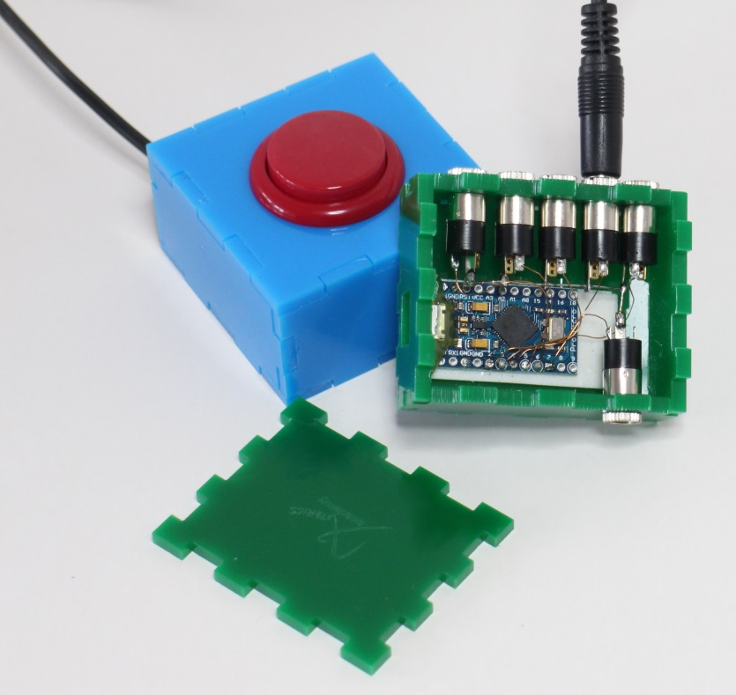

# Contact Information

#### The AsTeRICS Foundation

Webpage: http://www.asterics-academy.net

Email: office@asterics-academy.net

# Disclaimer

The University of Applied Sciences Technikum Wien and the AsTeRICS Academy project team do not assume any warranty and liability for the functionality of the set of Assistive Technology and the correctness of the documents handed over.

Additionally, the UAS TW is not liable for any damages to health due to the use of the Assistive Technology provided. The provided software applications and hardware modules are used at own risk !

# Acknowledgement

We want to thank Miriam Brenner and Fabian Schiegl for their support in creating this manual.

The AsTeRICS Academy is partly funded by the City of Vienna,   
Municipal department of Economic Affairs, Labour and Statistics (MA 23).

